Position Location: Buffalo, NY (2393 Main Street)
Job Classification: Full Time
Reports to: Vice President of Development

The Opportunity

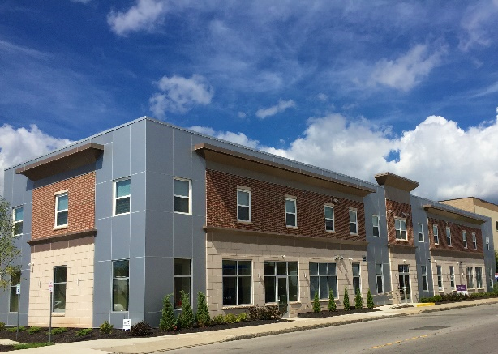
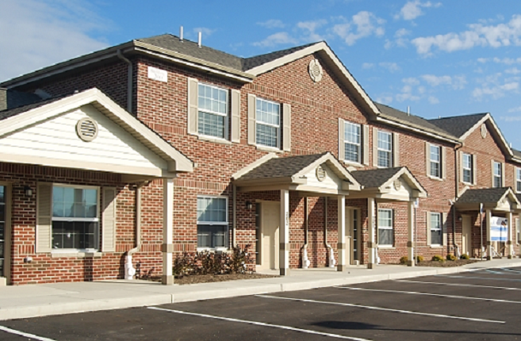
Belmont Housing Resources for WNY is a highly respected nonprofit organization in the Western New York Community. As an advocate and provider of affordable housing opportunities, Belmont serves over 15,000 low-income houses annually through their Section 8 (HUD) programs and other initiatives. The leadership team and staff are dedicated to providing assistance and opportunities for individuals and families to find and maintain safe and affordable homes. Affordable and accessible housing not only helps to strengthen families but builds stronger communities. Belmont is committed to expanding affordable housing opportunities through new construction and the adaptive reuse of existing structures, as well as empowering individuals with the education and counseling they need to find affordable rental opportunities, buy a home, understand financial management, prevent foreclosure, understand reverse mortgages, learn best practices in home maintenance, energy efficiency, and keep their homes healthy and safe.

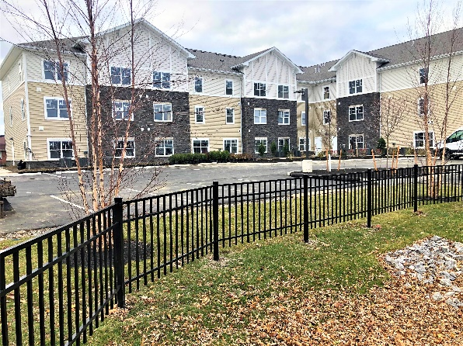
The Development Project Manager is an essential member of the Belmont Development Team reporting directly to the Vice President, working collaboratively with other Project Managers. This position is responsible for the overall administration and management of individual development and construction projects, ensuring alignment with project objectives, government regulations, and organizational goals in support of delivering new and rehabilitated housing units. The successful candidate will lead with integrity, providing strategic and operational oversight to ensure projects are administered seamlessly and successfully to achieve the goals of our organization, funding agencies and lenders.
Position Overview

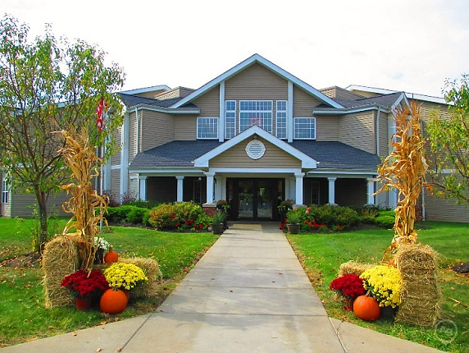

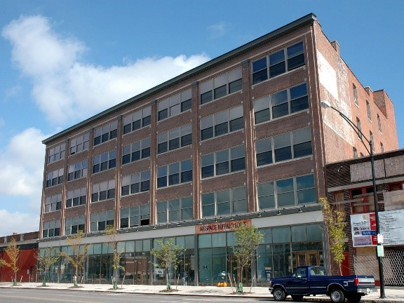
The Development Project Manager must be an organized leader that is self-motivated and able to manage multiple tasks concurrently. Ensuring Belmont accomplishes its mission in developing quality affordable housing, this position will need to maintain project schedules, cost track all project expenses, coordinate all professional design and contractor relationships, and work with funding agencies and lenders to satisfy all project financial requirements from initial loan closing through permanent financing. The successful candidate must have a track record of success in leading and managing multi-family development projects ranging between $10M and $50M in size and scope. Key competencies include:

- Ability to manage multiple project assignments concurrently.
- Self-motivated to ensure the timely completion of project tasks.
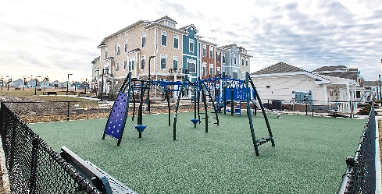
- Excellent organizational skills to include project scheduling, cost tracking and vendor management.
- Strong ability to communicate and operate as a leader of multiple project design and construction team members.
- Confidence with public speaking in representing the organization at project review meetings.
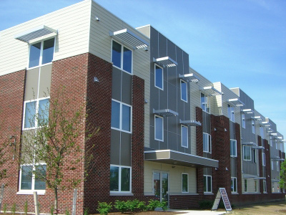
- Good understanding of construction financing mechanisms and typical underwriting formats.
- Ability to read and review construction drawing documents and critically assess their suitability to accomplish affordable housing program goals and residential unit design requirements.
- Attendance at construction coordination meetings during project construction to represent the Owner’s interest in reviewing work completion and processing payment applications.

Essential Duties & Responsibilities

The Development Manager plans, directs and coordinates activities of designated affordable housing programs and projects to ensure that objectives of projects are accomplished within the prescribed time frame and funding parameters by performing the following duties personally or in collaboration with department staff:

- Analyze community data to determine needs and satisfy the requirements of lender and agency financing applications.
- Identify affordable housing financing mechanisms to meet community needs.
- Work with the VP of Development to design programs or identify projects, and to prepare funding applications.
- Review funding proposals or plans to determine time frame, funding limitations, implementation procedures, staffing requirements, and allotment of available resources to various phases of program/project development.
- Establish work plans and staffing for each phase of programs and projects and arrange for the recruitment or assignment of program and project personnel.
- Confer with staff to outline work plans, assign responsibilities and scope of authority.
- Provide technical advice and be available to work with project teams to resolve problems and overcome complications related to project development.
- Direct and coordinate activities of program/project personnel to ensure projects progress on schedule and within prescribed budgets.
- Prepare and review status reports and modify schedules or plans as required.
- Prepare program/project reports for management, client, lenders, funders and others.
- Acts as primary resource for regulation interpretation and compliance.
- Coordinate program/project activities with government regulatory or other funding agencies including any necessary monitoring or compliance reporting.
- Represents the organization at public hearings and other public speaking engagements.
- Prepare financial underwriting summaries and pro formas to demonstrate financially sound project development and operating budgets in accordance with lender and funding agency requirements.
- Coordinate and lead project team meetings with clearly established agendas and critical path/action item tracking.
- Review and respond to Request for Proposal and Request for Qualification opportunities that arise for the organization related to single family and multifamily acquisition, rehabilitation and new construction.

Core Competencies Required

To perform the job successfully, an individual should demonstrate the following competencies:

- Analytical - Collects and researches data; Uses intuition and experience to complement data; Designs work flows and procedures.
- Design - Generates creative solutions; Uses feedback to modify designs; Demonstrates attention to detail.
- Problem Solving - Identifies and resolves problems in a timely manner; Gathers and analyzes information skillfully; Develops alternative solutions; Works well in group problem solving situations; Uses reason even when dealing with emotional topics.
- Project Management - Develops project plans; Coordinates and facilitates projects; Communicates changes and progress; Completes projects on time and budget.
- Technical Skills - Assesses own strengths and weaknesses; Pursues training and development opportunities; Strives to continuously build knowledge and skills; Shares expertise with others.
- Strong degree of initiative - Motivated, self-starter with ability to manage through multiple priorities.

Minimum Qualifications

To perform this job successfully, an individual must be able to perform each essential duty as noted above satisfactorily. The further requirements listed below are representative of the knowledge, skill, and/or ability associated with the essential duties. Reasonable accommodations may be made to enable individuals with disabilities to perform the essential functions.

- Education and/or Experience
Candidates must demonstrate either of the following:
- Bachelor's degree (B.A./B.S.) from four-year college or university and at least five years related experience, such as securing funding for affordable housing, affordable housing project management, utilization of low income housing tax credits, project management experience with market rate development, etc.
OR
- Masters Degree (M.A. /M.S.) from college or university and at least two years related experience as indicated directly above within this paragraph.

  - Language Skills
Ability to read, analyze, and interpret common scientific and technical journals, financial reports, and legal documents. Ability to respond to common inquiries or complaints from customers, regulatory agencies, or members of the business community. Ability to write speeches and articles for publication that conform to prescribed style and format. Ability to effectively present information to top management, public groups, and/or boards of directors.

  - Mathematical Skills
Ability to calculate figures and amounts such as discounts, interest, commissions, proportions, percentages, area, circumference, and volume. Ability to apply concepts of basic algebra and geometry. Ability to prepare and use complex project budgets.

  - Reasoning Ability
Ability to solve practical problems and deal with a variety of complex variables in situations where only limited standardization exists. Ability to interpret a variety of instructions furnished in written, oral, diagram, or schedule form.

  - Computer Skills
To perform this job successfully, an individual should have strong computers skills, and knowledge of Database software; Internet software; Project Management software; Proficiency with Spreadsheet software and Word Processing software is essential.

  - Transportation
This position requires regular traveling to construction sites and public/community group meetings throughout the Buffalo/Niagara region. As such, the employee must have access to a reliable automobile. Belmont will reimburse the employee for work related use of their personal vehicle in accordance with federal mileage rates.

  - Certificates, Licenses, Registrations
None required.

  - Other Skills and Abilities
Thorough knowledge of federal, state, local and private financing programs for affordable housing and applicable regulations is preferred. Strong ability to advance the progress of assigned projects. Proven ability to work effectively with lenders, investors, public officials and low-income populations. Skill in financial analysis, knowledge of construction and writing skills. Capacity to develop a long-range 'vision' for existing and potential projects.

  - Physical Demands
The physical demands described here are representative of those that must be met by an employee to successfully perform the essential functions of this job. Reasonable accommodations may be made to enable individuals with disabilities to perform the essential functions. While performing the duties of this job, the employee is frequently required to sit, talk, walk or hear. The employee is regularly required to stand and walk for extended periods and will at times be required to travel by vehicle to offsite construction locations for the purpose of conducting construction coordination meetings. The employee will be required to wear personal protective equipment including a hardhat, eye protection and vest when accessing construction sites.

  - Work Environment
The work environment characteristics described here are representative of those an employee encounters while performing the essential functions of this job. Reasonable accommodations may be made to enable individuals with disabilities to perform the essential functions. The work environment generally consists of a professional office workspace. The noise level in the work environment is usually moderate except for those occasions when staff are required to access active construction sites. Additionally, the duties of this job may require the employee to travel to and attend public board meetings (i.e. Town Board, Planning Board, Zoning Board of Appeals, etc.) and community association meetings that are held either after 5:00 pm on regular workdays as well as certain meetings that may be scheduled during weekends.

Benefits Overview

Belmont Housing Resources offers a comprehensive benefits plan designed to meet the needs of all our employees:

• Medical/Dental/Vision Insurance
• 401(k) retirement plan with matching contributions
• Short-term and long-term disability coverage
• Paid FMLA
• Group life insurance
• Accident and Critical Illness insurance
• Flexible Spending and Health Savings accounts
• Paid time off and paid holidays
• Tuition reimbursement
• Flexible work schedules
• Free parking

To Apply

Interested Applicants should submit a cover letter and resume by accessing the job application portal available through the Belmont Housing website at the following link: https://www.belmonthousingwny.org/careers-employment/

The application filing deadline is 5:00 pm on Monday, May 17, 2021.

Belmont Housing Resources for WNY is an Equal Opportunity Employer, and as such affirms the right of every person to participate in all aspects of employment without regard to race, religion, color, national origin, citizenship, sex, sexual orientation, gender identity, age, veteran status, disability, genetic information, or any other protected characteristic. If you are interested in applying for employment and need special assistance or an accommodation to apply for a posted position, contact our Human Resources department at 716-884-7791. For further information about Equal Opportunity, please click on the links below:

EEO is the Law

